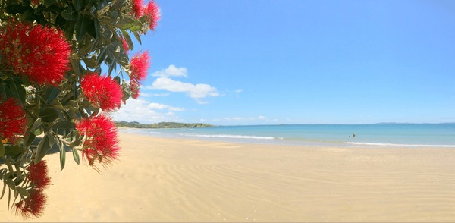
Seasons Greetings & Meri Kirihimete
from all the team at MERAS
MERAS recognises that many of you will continue to work over the Christmas and New Year period, to support maternity services across the motu. We hope that you all will have some time to enjoy the holiday season and do the things that re-energise and bring joy to you.
The public holidays for Christmas and New Year fall on a Thursday and Friday this year. We have had some questions from members about how the public holiday provisions will apply to them.
If you work for Health NZ | Te Whatu Ora maternity clinics or outpatient services which will not be functioning on the public holidays the following options might apply:
- If the work you do has moved to the working day of Monday, Tuesday or Wednesday and the Thursday and Friday are now your days off for the week, you will be eligible for an alternate public holiday to be credited to you, if you meet the provisions in 15.9 of the MERAS SECA (as below).
- If the work you do has been cancelled for the Thursday and Friday and these are now additional days off for you that week, they will be ‘public holidays on the day they fall’.
If you work in an inpatient maternity service or a 24/7 midwifery role, it is likely that you will just be rostered your usual days off based on your FTE, unless you are on annual leave.
- If you are rostered a day off on the public holidays you will be eligible for an alternate public holiday to be credited to you, if you meet the provisions below.

  - Off duty upon which the employee does not work:
Fulltime employees –
Where a public holiday, and the weekday on which the observance of a public holiday is transferred where applicable, are both rostered days off for an employee, they will be granted one alternative holiday in respect of the public holiday.
Part-time employees –
Where a part-time employee’s days of work are fixed, the employee shall only be entitled to an alternative holiday if the day would otherwise be a working day for that employee.
Where a part-time employee’s days are not fixed, the employee shall be entitled to an alternative holiday if they worked on the day of the week that the public holiday falls more than 40 % of the time over the last three (3) months. Payment will be relevant daily pay.
The provisions described above are similar for MERAS members employed in the Funded Sector, but the wording may be different. Please contact David or Caroline if you are unsure that you are being treated fairly.
MERAS staff availability over Christmas period
MERAS staff will continue to be available over the holiday period. If you need support or advice, please contact us via email or phone 027 6888 372 for Caroline or 027 276 9999 for David.

We’ll be in touch in 2026 which promises to be a big year with ongoing work from collective agreement settlements, and a General Election at the end of it.

Best Wishes
Caroline, David, Karen, Jess and Julie
